Project 2: WordPress Documentation
- How to access your Site
Go to http://dev-hotels1.pantheonsite.io/wp-login.php?loggedout=true
You are going to come across the log-in form as stated below. Here you have to enter your credentials and click on «Log-in».
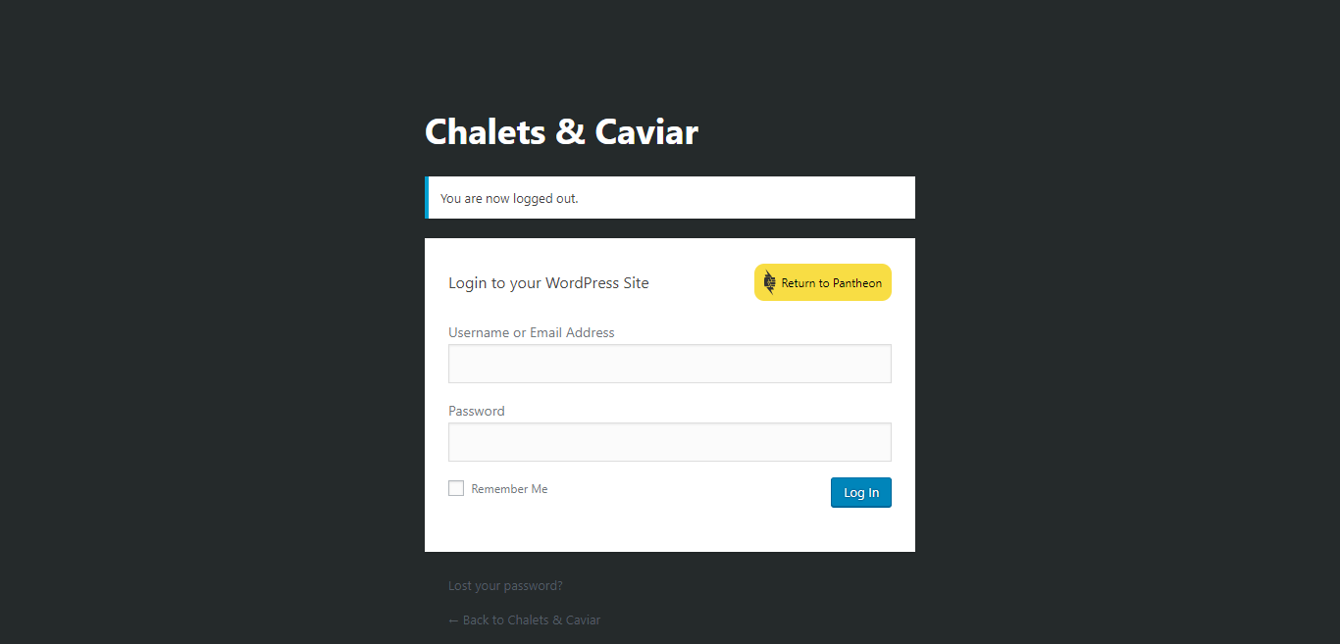
- Access Configuration
If you want to add users to be able to add, edit and delete chalets you have to first add new the users in the WordPress and give them a profile. Only users given Administrator profile can add new users. For instance Agency director Mr Smith, has administrator rights so he will be able to add new users and not other agency employees. Users have to sign in the WordPress and then get access to the Properties.
Agency Director Mr Smith – Administrator profile has full access
Username: smith Password: smith03
Agency employees -Editor profiles with limited access only
Nathan James Username: nathan12 Password:nathan12
Melissa Williams Username:melissa Password: melissa16

1. User Management
How to add new Users
If you want to add a new user, click on «Users» -> Add New
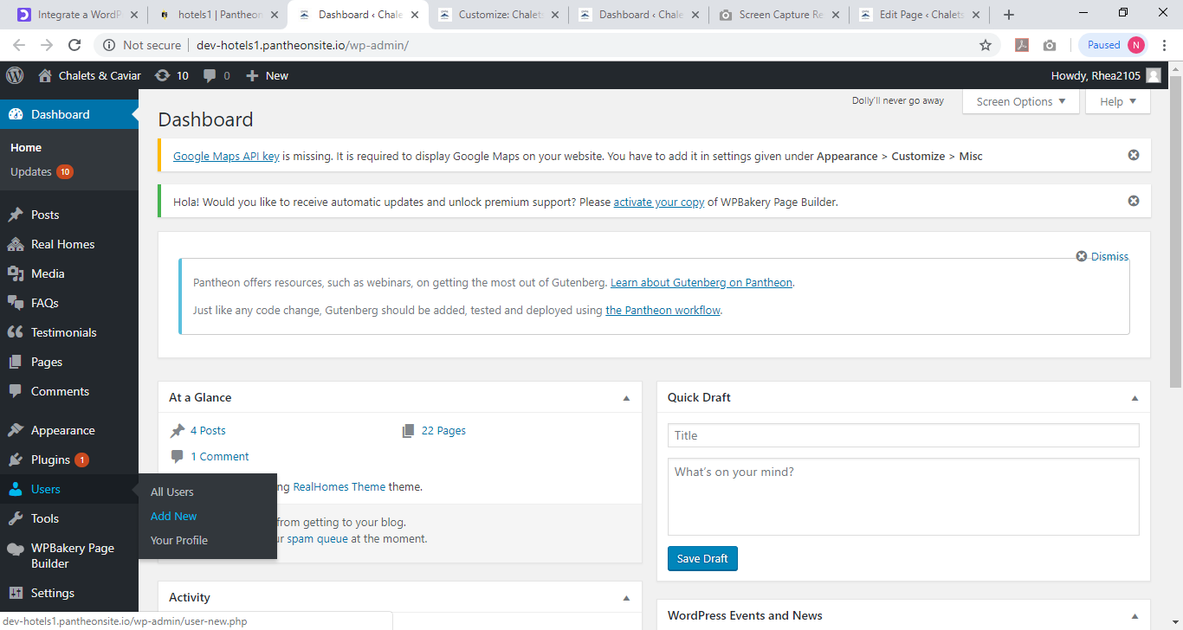
Here, add all necessary Information and assign a role to the new user. You can choose between Administrators, Contributor, Editor (Agency Employee), and Author.
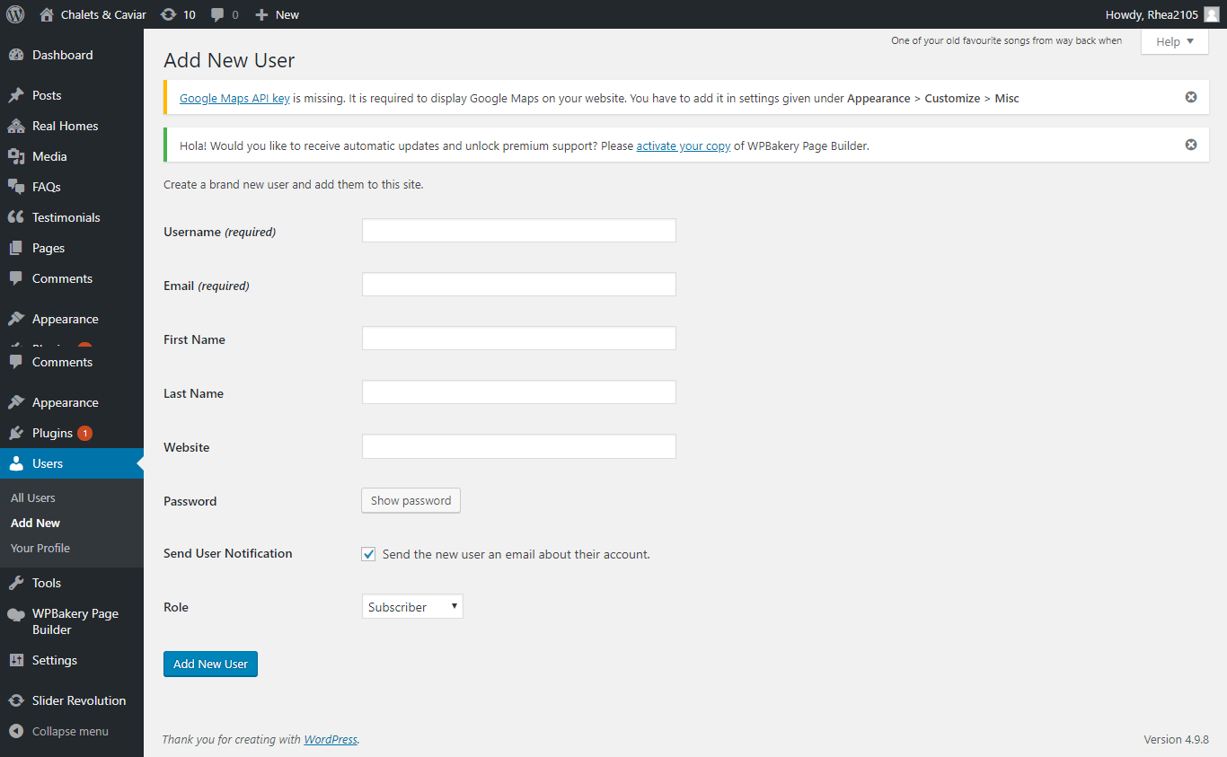

2. How to add new chalets
Under «Real Homes»-> «Properties», you have the option to add a new property.
Once you click on «Add New», another entry form appears where you can enter all the necessary data about the new property, like images, size of the lot, assign agents and much more.
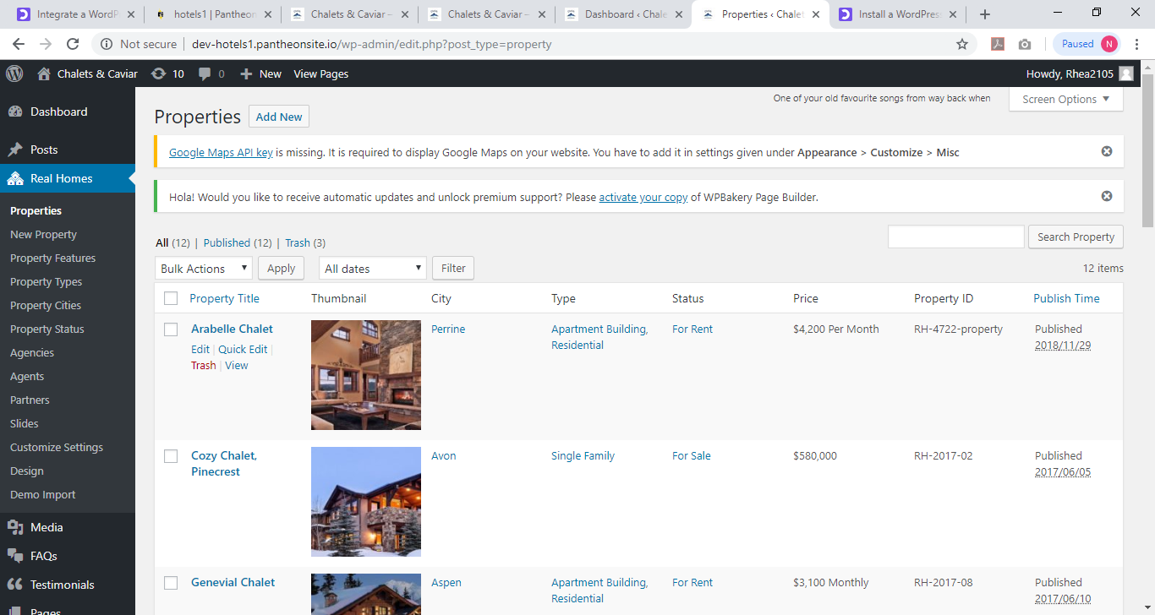

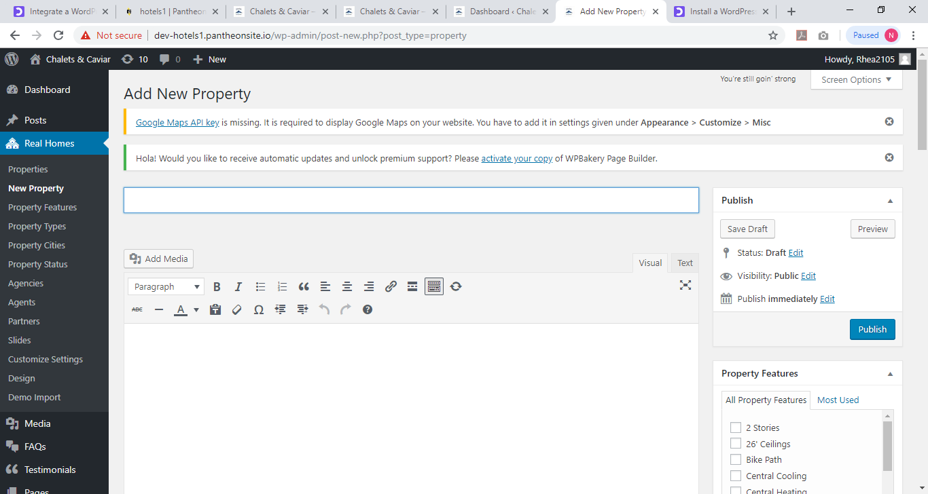

3.How to edit Property
If you want to edit your Property, you go to Properties and click on edit
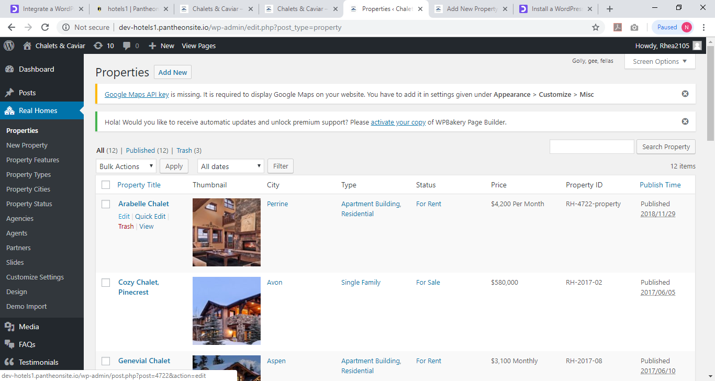

On edit Property, you can add the details of the property for instance the number of bedrooms, kitchen if it has central heating; its property status is it for sale or rent and the amount the Property is for sale or Rent.
Click on Update to save changes.
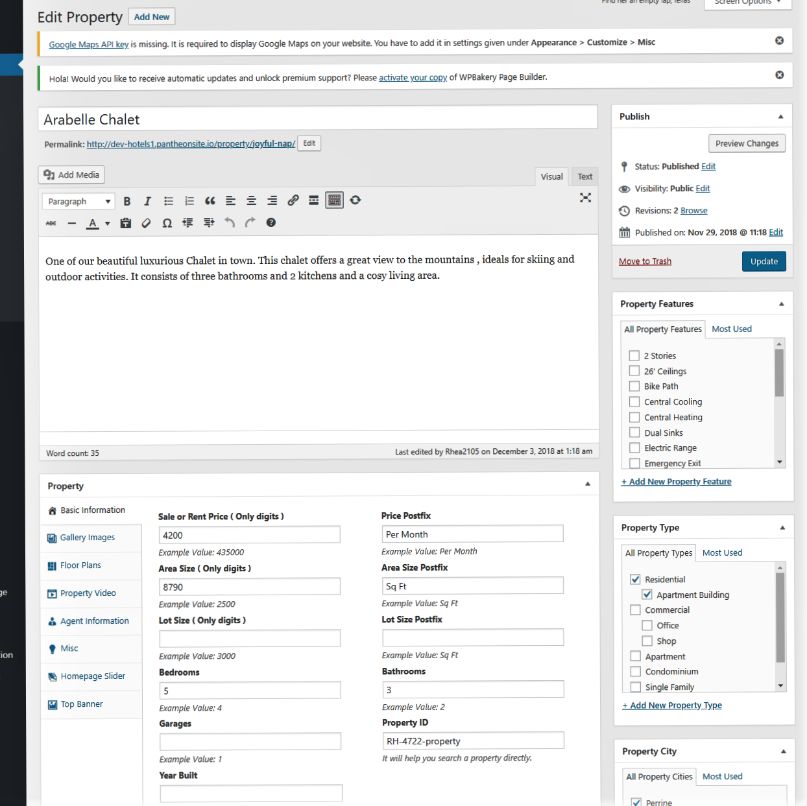

4. How to delete Property
In order to delete any property. Go to Properties and select the property you want to delete and click on Trash
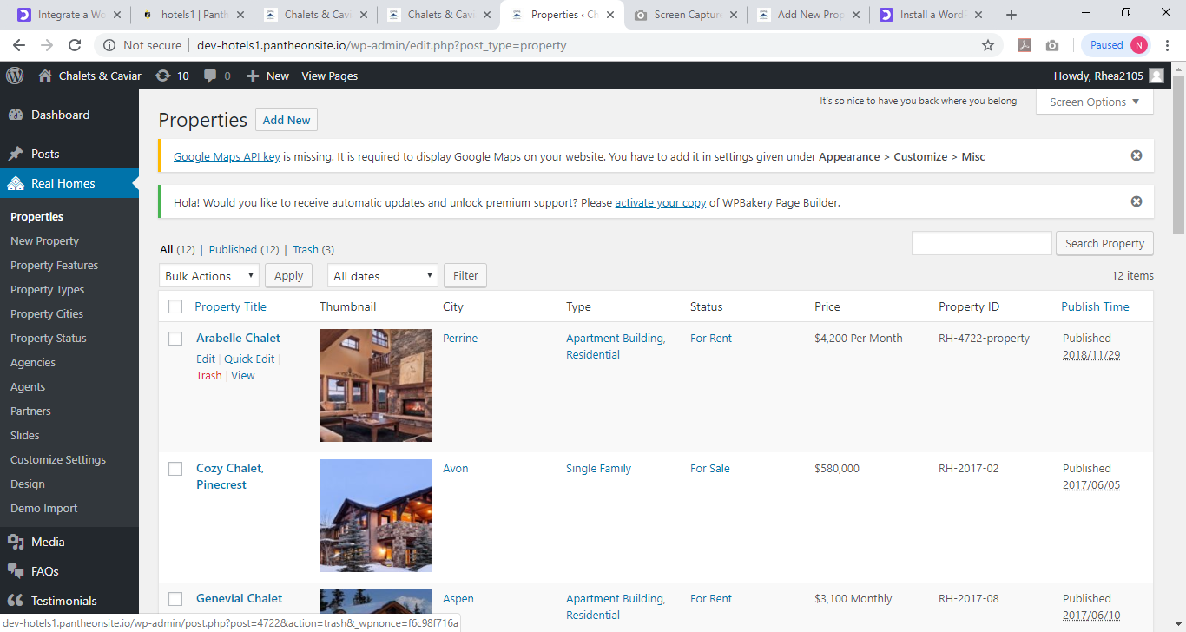
5. How to check Status of Property
You can view the different number of Chalets that are on either rent or sale. Go to Properties and Property Status
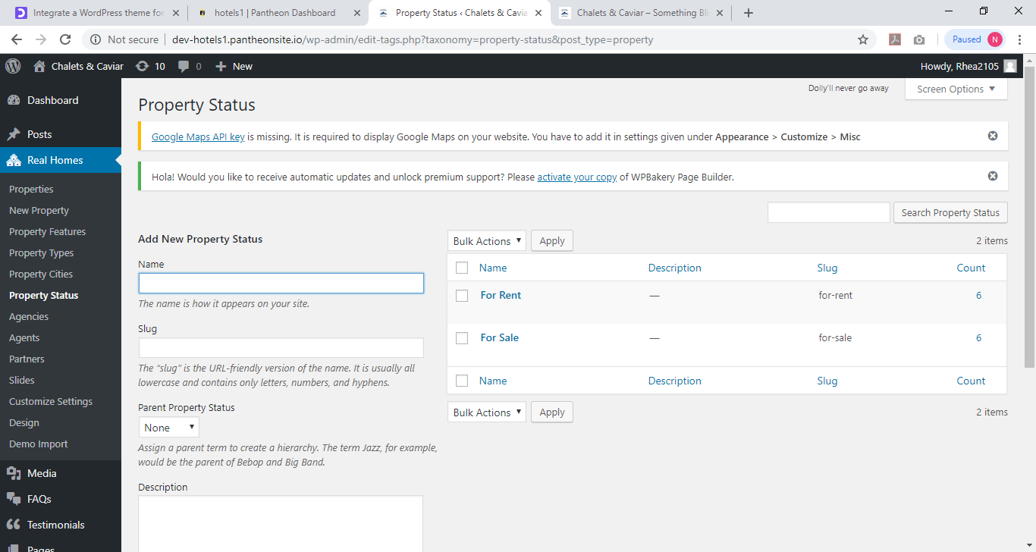

6. Check the Property Features
Go to Properties and then Property Features. Here are able to separate all the different properties that you have in different properties for example how many properties have central heating, fire exit and 2 ceilings.
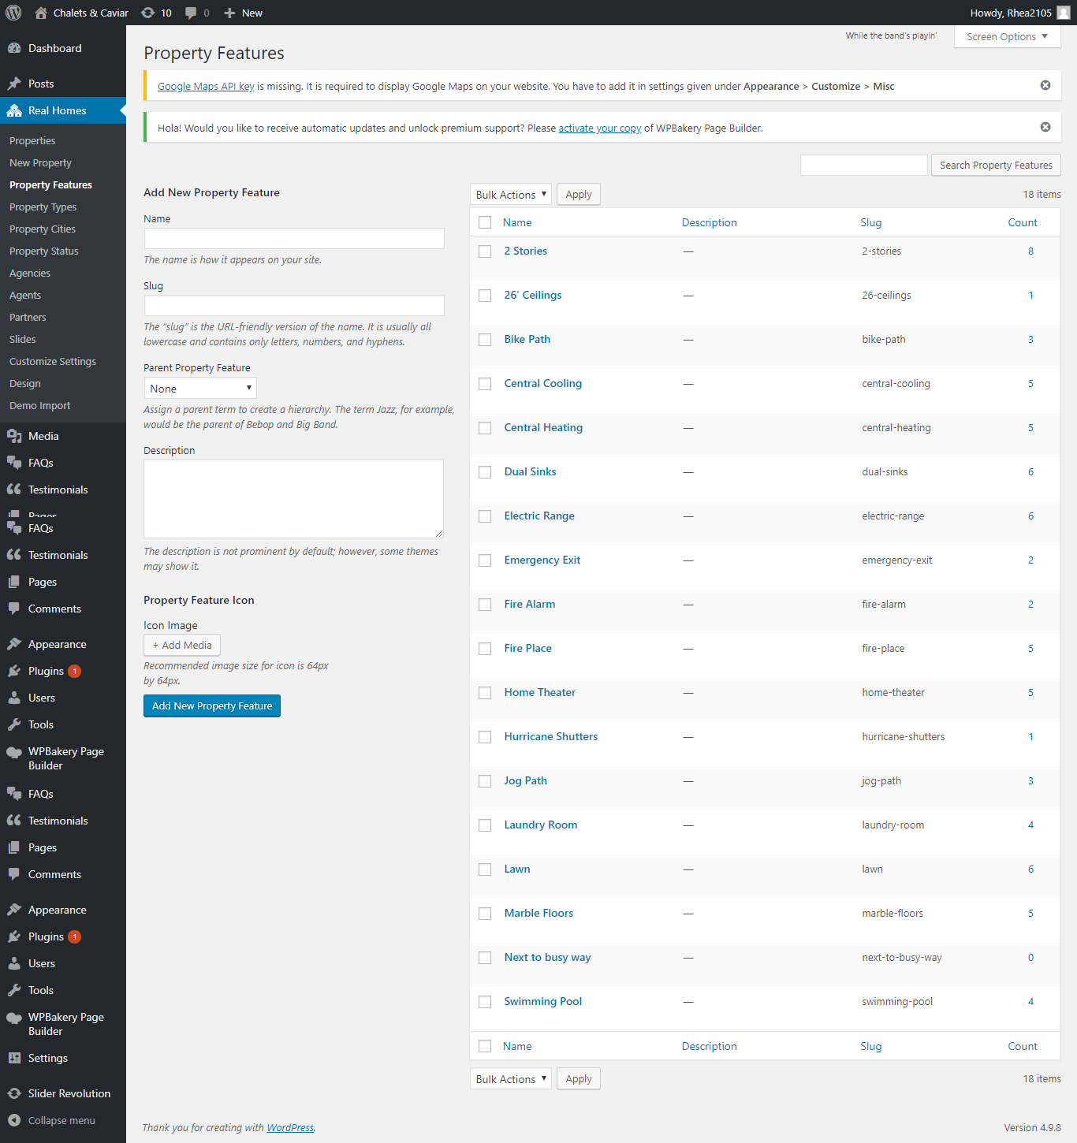
7. How to check which Property is for Residential , single family , apartment or villa.
Go on Properties, Property Types
